MailHog
# Source: AI Source: Provided by: [Data Path: Persons Table -> ID Column: 1, Name_En Column: Motasem Essam] -> From: [Chatgpt (GPT‑5 Mini)] on [1/21/2026]
What is MailHog?
MailHog is an open-source fake SMTP server designed for developers to test email sending locally. It intercepts outgoing emails and provides a web interface and API to view them—without actually sending them to real recipients (github.com).

🛠️ Main Features
# Source: AI Source: Provided by: [Data Path: Persons Table -> ID Column: 1, Name_En Column: Motasem Essam] -> From: [Chatgpt (GPT‑5 Mini)] on [1/21/2026]
- SMTP & ESMTP: Supports standard SMTP, extended SMTP (AUTH, PIPELINING) (github.com).
- Web UI + API: Messages are shown in a browser (default on port 8025) and accessible via JSON (github.com).
- In‑memory, file, or MongoDB storage: Configurable persistence .
- “Jim” Chaos Monkey: Simulate failures like dropped connections, authentication errors or rate limits (github.com).
- Release mode: Optionally forward captured emails to a real SMTP server (github.com).
- Attachments & MIME support: Download attachments, view HTML/text/source; supports multipart and encoded headers (github.com).
- Lightweight & portable: Single Go binary runnable across platforms; also available via Homebrew, Docker, packages (github.com).

🚀 Why use it?
# Source: AI Source: Provided by: [Data Path: Persons Table -> ID Column: 1, Name_En Column: Motasem Essam] -> From: [Chatgpt (GPT‑5 Mini)] on [1/21/2026]
- Instant local email testing, no need for real SMTP or internet connectivity.
- Avoid accidental real emails during testing cycles.
- Test email layouts, links, HTML, attachments in a browser using the UI.
- Automate in CI by querying the API to assert emails were sent.
- Test failure scenarios reliably with the Chaos Monkey (runcloud.io, dotruby.com).

🧩 Typical Setup
# Source: AI Source: Provided by: [Data Path: Persons Table -> ID Column: 1, Name_En Column: Motasem Essam] -> From: [Chatgpt (GPT‑5 Mini)] on [1/21/2026]
- Install MailHog
  - Download binary from GitHub
  - Use brew install mailhog on macOS (formulae.brew.sh)
  - Or docker run -p 1025:1025 -p 8025:8025 mailhog/mailhog (mailtrap.io)
- Start MailHog (default ports: SMTP 1025; HTTP 8025).
- Configure your app to send SMTP on localhost:1025.
For example, in PHP configure sendmail_path to mhsendmail or SMTP host–port analogously (mailtrap.io, kinsta.com).
- View emails via the browser at http://localhost:8025, explore logs via JSON API.

📚 Integrations
# Source: AI Source: Provided by: [Data Path: Persons Table -> ID Column: 1, Name_En Column: Motasem Essam] -> From: [Chatgpt (GPT‑5 Mini)] on [1/21/2026]
MailHog integrates smoothly across many languages and frameworks:
- PHP applications via mhsendmail wrapper
- Ruby on Rails using ActionMailer smtp_settings pointing to localhost:1025 (dotruby.com)
- Docker‑based environments
- Many CMS like Kirby, frameworks, and CI pipelines

✅ Alternatives
# Source: AI Source: Provided by: [Data Path: Persons Table -> ID Column: 1, Name_En Column: Motasem Essam] -> From: [Chatgpt (GPT‑5 Mini)] on [1/21/2026]
Tools like MailCatcher, Papercut SMTP, FakeSMTP, and paid services like Mailtrap offer similar functionality. MailHog is praised for its simplicity, web UI, and extensibility—though some alternatives may offer enhanced analytics or email previews (github.com, getkirby.com, mailtrap.io).

TL;DR
# Source: AI Source: Provided by: [Data Path: Persons Table -> ID Column: 1, Name_En Column: Motasem Essam] -> From: [Chatgpt (GPT‑5 Mini)] on [1/21/2026]
MailHog is a developer-friendly fake SMTP server that makes prototyping and testing email workflows painless. It captures emails, offers a UI and API to inspect them, supports failure testing, and is easy to run locally—ideal for safe, efficient email development.

Download MailHog
# Source: ScreenShots Source: Provided by: [Persons Table -> ID Column: 1, Name_En Column: Motasem Essam] -> Tool: [Lightshot Program] -> From [Site: Google Search: All: MailHog] on [1/21/2026]
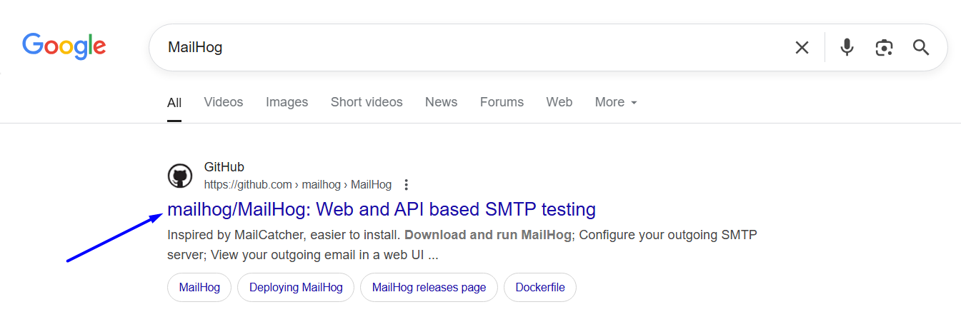
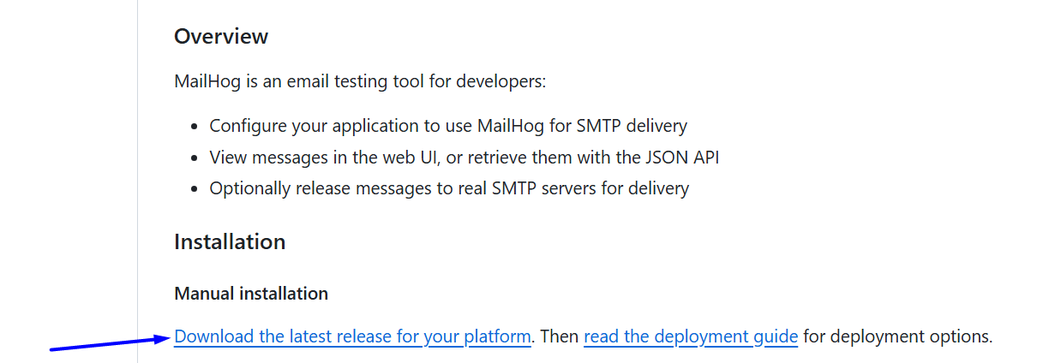
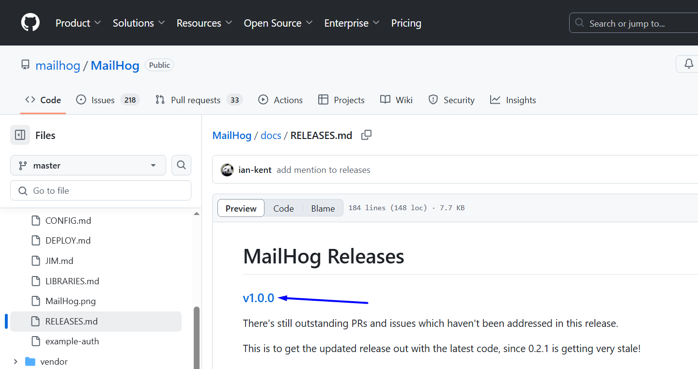
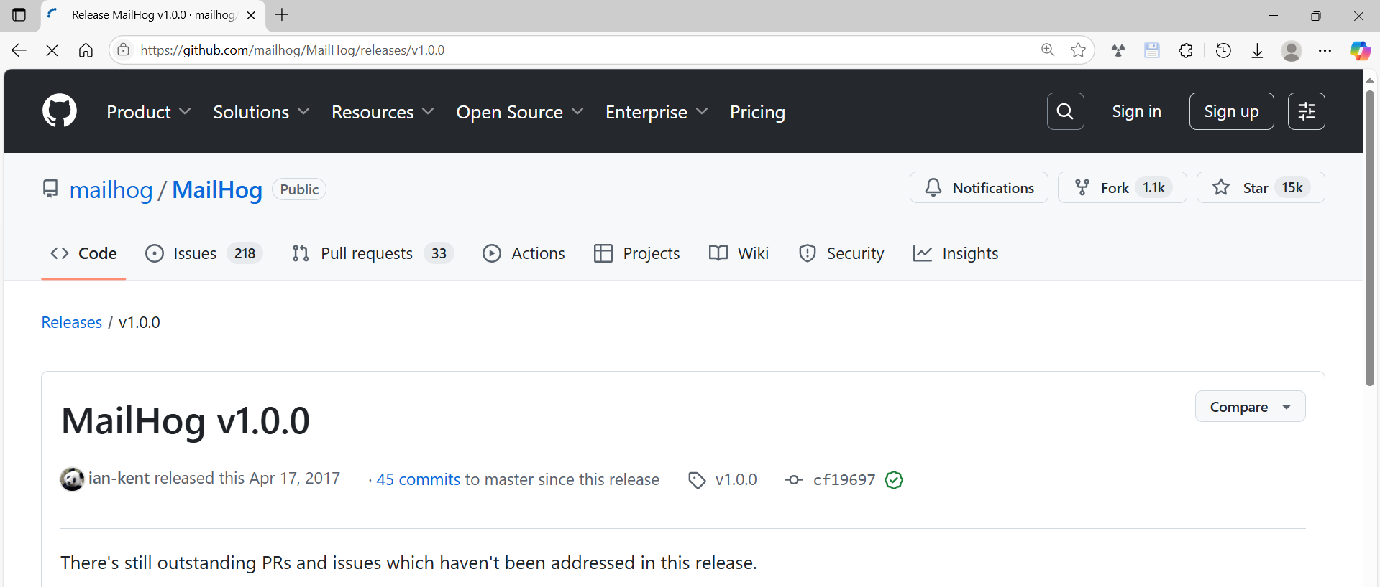
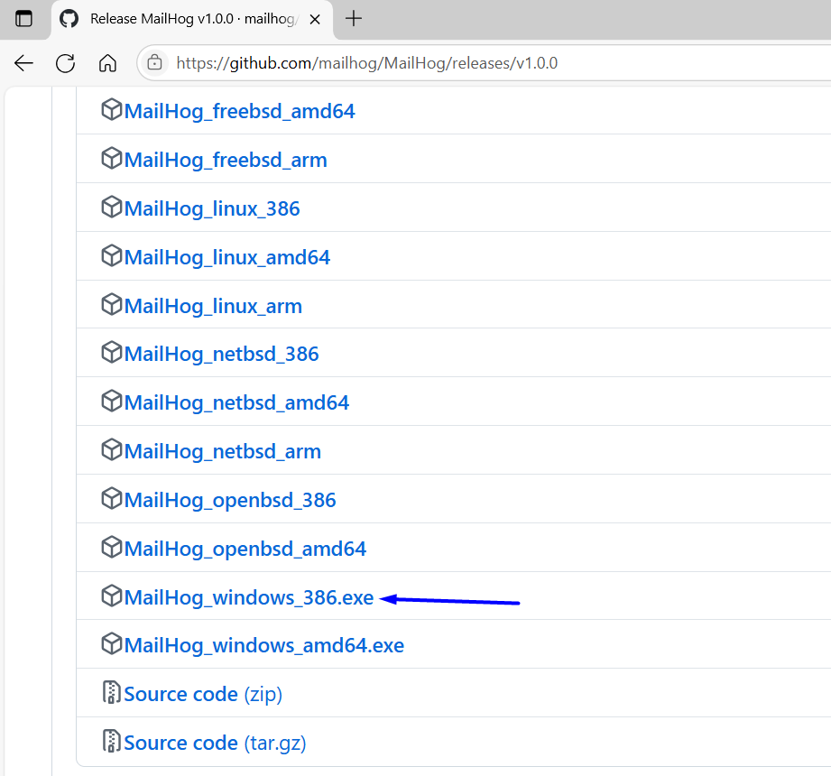
https://github.com/mailhog/MailHog/releases/download/v1.0.0/MailHog_windows_386.exe

Run MailHog
# Source: ScreenShots Source: Provided by: [Persons Table -> ID Column: 1, Name_En Column: Motasem Essam] -> Tool: [Lightshot Program] -> From [Operating system: Windows: Windows 10: MailHog_Windows_386.exe] on [1/21/2026]
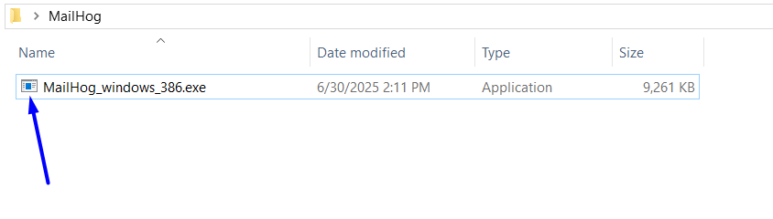
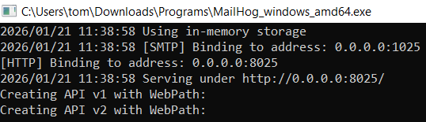

✅ What This Log Means:
# Source: AI Source: Provided by: [Data Path: Persons Table -> ID Column: 1, Name_En Column: Motasem Essam] -> From: [Chatgpt (GPT‑5 Mini)] on [1/21/2026]
2026/01/21 11:38:58 Using in-memory storage
2026/01/21 11:38:58 [SMTP] Binding to address: 0.0.0.0:1025
[HTTP] Binding to address: 0.0.0.0:8025
2026/01/21 11:38:58 Serving under http://0.0.0.0:8025/
Creating API v1 with WebPath:
Creating API v2 with WebPath:

🔹 Using in-memory storage
MailHog is storing emails in RAM only.
- Emails will disappear when MailHog restarts
- This is the default behavior
- No disk/database is being used
✅ Totally fine for local development

🔹 [SMTP] Binding to address: 0.0.0.0:1025
MailHog’s SMTP server is running.
- Listens on port 1025
- 0.0.0.0 means it accepts connections from any network interface
- Your application should send emails to:
  - Host: localhost
  - Port: 1025
Example config:
MAIL_HOST=localhost
MAIL_PORT=1025

🔹 [HTTP] Binding to address: 0.0.0.0:8025
MailHog’s web UI is running.
- Access it in your browser at:
- http://localhost:8025
- This is where you view captured emails

✅ Summary
MailHog is fully running:
Service | Address
SMTP | localhost:1025
Web UI | http://localhost:8025

Run MailHog Web interface
# Source: ScreenShots Source: Provided by: [Persons Table -> ID Column: 1, Name_En Column: Motasem Essam] -> Tool: [Lightshot Program] -> From [Operating system: Windows: Windows 10: Microsoft Edge] on [1/21/2026]

http://localhost:8025/
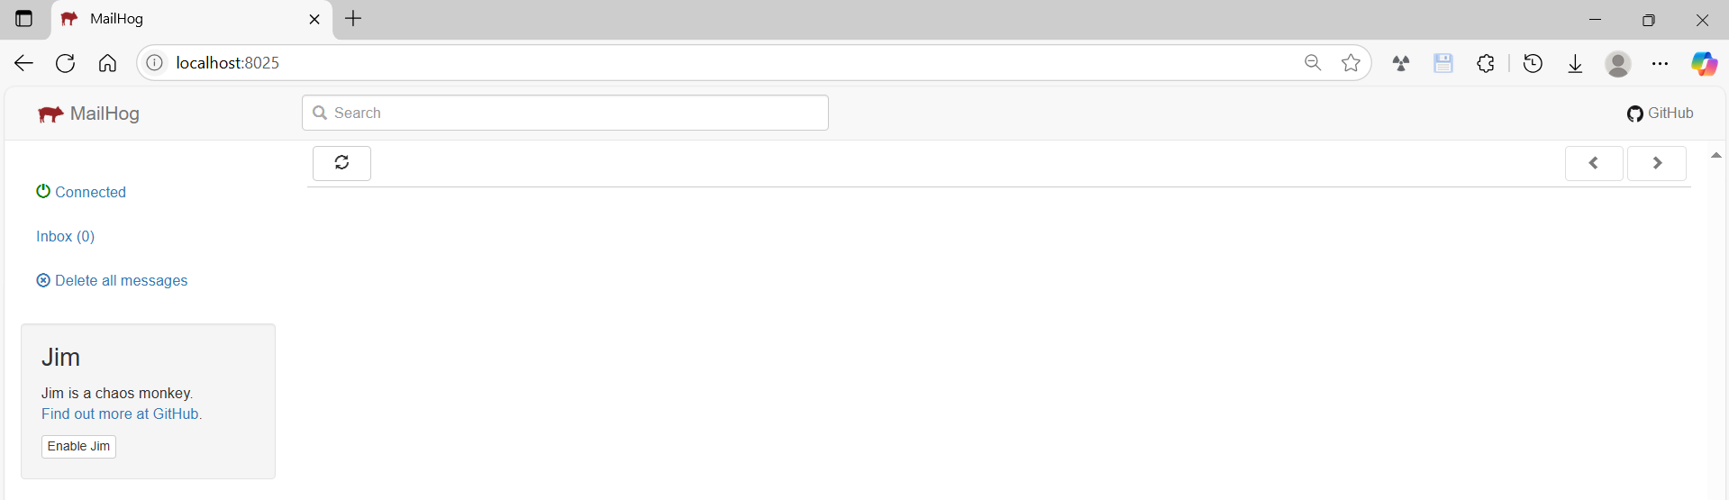
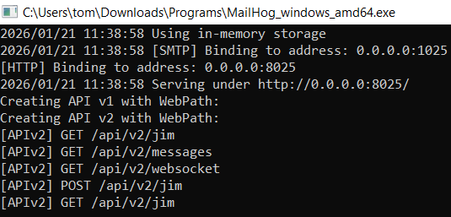

✅ What This Log Means:
# Source: AI Source: Provided by: [Data Path: Persons Table -> ID Column: 1, Name_En Column: Motasem Essam] -> From: [Chatgpt (GPT‑5 Mini)] on [1/21/2026]
[APIv2] GET /api/v2/jim
[APIv2] GET /api/v2/messages
[APIv2] GET /api/v2/websocket
[APIv2] POST /api/v2/jim
[APIv2] GET /api/v2/jim

🔹 [APIv2] GET /api/v2/jim
This is an internal MailHog endpoint used by the web UI.
- “jim” is MailHog’s internal name for its UI session/state
- The browser requests UI configuration and status
✅ Nothing to worry about

🔹 [APIv2] GET /api/v2/messages
The web UI is asking MailHog:
“Give me the list of captured emails”
This request happens:
- When you open the MailHog UI
- When you refresh the page
- When new emails arrive
If no emails exist yet, it just returns an empty list.

🔹 [APIv2] GET /api/v2/websocket
MailHog opens a WebSocket connection so the UI can:
- Receive new emails in real time
- Avoid page refreshes
This is how emails instantly appear in the UI.

🔹 [APIv2] POST /api/v2/jim
The browser sends UI state back to MailHog:
- Filters
- Selected message
- UI preferences
Purely internal UI behavior.

🔹 [APIv2] GET /api/v2/jim (again)
UI refresh or state sync after changes.

✅ Bottom Line
These logs mean:
✔ MailHog UI is open in a browser
✔ API v2 is working
✔ WebSocket live updates are active
✔ Everything is functioning correctly

🧠 When to Be Concerned
Only worry if you see things like:
- connection refused
- bind: address already in use
- Missing emails when your app sends them

